Chapter 18, Problem 56.

The voltage across a 1-Ω resistor is 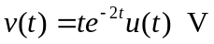. (a) What is the total energy absorbed by the resistor? (b) What fraction of this energy absorbed is in the frequency band  

